Stonehill Nursery
School

Attendance Policy

Head Teacher: Louise Foster

Chair of Governors: Russell Langley

Policy Approved by: Governors Behaviour and Safety Committee

Policy reviewed by: Governors Behaviour and Date: 23 October 2018
Safety Committee

Policy reviewed by: Governors Behaviour and Date: 1 October 2019
Safety Committee

Policy reviewed by: Governors Behaviour and Date: 9 March 2021
Safety Committee

Policy reviewed by: Governors Behaviour and Date: 24 January 2023
Safety Committee

ATTENDANCE

Stonehill Nursery School seeks to ensure that all pupils receive an education which will give them the appropriate skills that will equip them for life.

Although we recognise that attending nursery is not statutory, we hope to work with parents and carers to develop good habits of punctuality and attendance in children. From the beginning of a child’s learning journey at school, parents and carers are informed of the importance of good attendance and punctuality through home visit discussions with staff. Children learn and develop most between the ages of birth to five years - developing good habits now will benefit them through their entire school life and beyond. Consistency and routine are also very important for young children and greatly benefits their wellbeing.

Good attendance results in happy, settled children who make good progress.

Aim of the Policy
Our Attendance Policy aims to ensure open and honest conversations with parents/carers to promote the highest possible levels of regular attendance which helps to establish a foundation for all future learning. We aim to do this by re-enforcing positive messages with parents and carers, working collaboratively to identify and resolve barriers to attendance and raising awareness of the adverse effects to children of non-attendance.

Procedures
- Parents/carers are expected to bring their children to school, on time, every day the school is open unless the reason for the absence is unavoidable. Children should arrive at 9:00am for morning session or 12:45pm for the afternoon session
- If children are absent from school due to illness, parents/carers are asked to contact the school before 8:30am for children who attend morning sessions, or 12:30pm for those attending in the afternoon. Parent/carers' explanations of children's absence will be recorded and passed to the Lead Teacher.
- If children are absent and school has not been informed, we will try to contact parents/carers via telephone call requesting contact with the school. All such attempts to communicate with parents/carers regarding their child's absence will be recorded. If children are known to Social Care, this service will be informed on the first day of a child's absence.
- If the school has not had a response from parents/carers and the child remains absent for a second day, school will try to contact other adults identified on the school admission document. In circumstances where school feels the family is vulnerable, a member of staff may make an unannounced visit to the family home in a further attempt to make contact. Social Care will also be informed.
- In all cases where a child is absent for three days and we have not had contact from parents or carers, a member of staff will make an unannounced home visit to be assured of the family's welfare.
- The school will be proactive in its support of parents and carers to try to identify barriers to attendance and resolve any issues. This may include actions such as offering Early Help to support the family, involving other agencies or, where possible, offering alternative or extended sessions to ensure their children's attendance improves.

Attendance Monitoring
See Appendix 1 for the absence monitoring flowchart, Appendix 2 for the attendance letters and Appendix 3 for the letter regrading lateness.

The administrator will conduct the monitoring of attendance for all children every week. During this monitoring, if the school identifies poor attendance, including patterns of non-attendance, it will take the following actions to identify barriers and support parent/carer engagement in improving their child's attendance:

- Have an initial conversation with parents/carers and the Nursery lead teacher/administrator.
- Send an initial letter to parents/carers, explaining the impact on children's learning and progress (letter 1, Appendix 2)
- Invite parents/carers, via letter two, to discuss their child's attendance with the administrator (letter 2, Appendix 2).
- Send an invitation to meet with the headteacher, via letter three, with the aim of resolving attendance issues.

During this process, children's attendance will be monitored more regularly and, where a child's attendance improves, this will be positively acknowledged with parents/carers.

Authorised Absences
As a school, we are aware that there may be occasions where children's absence cannot be avoided, for example if they have to attend medical appointments or there is a family emergency. These such absences will be authorised.

We actively discourage parents/carers from taking children on family holidays during term time as this can impact negatively on their progress. Only in exceptional circumstances will such absences be authorised on the completion of the Planned Absence Form (see Appendix 3). If a family chooses to take their child out during term time, they are only able to have up to 10 school days off for their children for the duration of time their child is at Stonehill Nursery School. If a child is out of school for longer than this period or for more than one occasion, the school reserves the right to withdraw the place. The only exceptions for this will be dependent upon circumstances and if the child has any additional needs.

Days of religious observance - This is absence to take part in any day set aside exclusively for religious observance by the religious body to which the parents belong, including religious festivals. The school will be sensitive to such requests but the request must be made prior to absence. Only one day will be authorised per religious observance when this day falls in term time.

Promoting the attendance and punctuality of our children
The school will promote the benefits of good attendance and punctuality to nursery through:
- Certificates (awarded every half term)
- Hoppity (our special good attendance cuddly toy)

Collecting children from nursery
Children must be collected form nursery by someone 16 years of age or older. If someone different is collecting your child you must inform a member of staff when dropping your child off or phone the nursery and give the name and relation of the person collecting your child.

Collection will only be allowed at the end of a session unless there is written evidence of an appointment, e.g. Doctor’s letter.

Appendix 1
Attendance flowchart

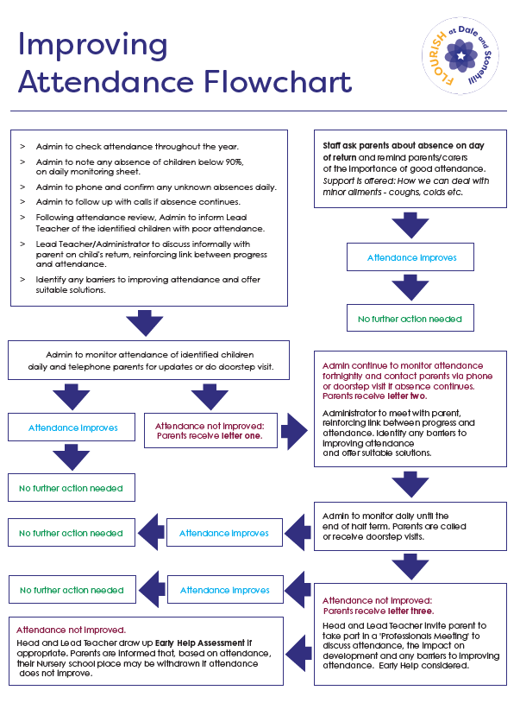

Appendix 2
Attendance Parent/Carer Letter 1 - to be added to letterhead paper

GOOD ATTENDANCE IS IMPORTANT

Dear,

At Stonehill Nursery School, we are committed to ensuring all children benefit from their education by attending nursery regularly. Attending nursery each day enables children to settle into the learning environment, feel confident to join in new and exciting activities and make friends, this in turn, helps children to feel good about themselves. This is the time when they learn valuable social skills that enable them to make those most meaningful relationships and strong bonds with both children and adults - these are all vitally important to being happy. We cannot stress enough the importance of regular nursery attendance and the impact this will have on your child's learning and progress moving forward.

We miss your child when they are not here and the contribution you and your child make. We want your child to be the best they can be and this can be done by attending nursery every day. We are here to help and provide the best nursery education for every child. If you have any concerns about anything at all, then please do not hesitate to speak to any member of the nursery team.

Attendance is monitored each half term and if your child's attendance falls to less than 87% (the equivalent of 25 days' absence over a whole school year), we will contact you and discuss how we can work together to improve your child's attendance.

Yours sincerely

Appendix 2
Attendance Parent/Carer Letter 2 - to be added to letterhead paper

Dear

As you know, we have been monitoring your child's attendance over the last few weeks. Unfortunately, your child's attendance has remained below 87%.

We would like to support you to improve your child's attendance and therefore invite you to meet with Miss Henson on:

Regular attendance at nursery has been shown to have a significant impact on children's achievement. Attendance at nursery establishes good habits from an early age and contributes to the development of a positive approach to school and education.

Please be advised that we are a popular nursery school with a waiting list and should attendance remain below the expected 87%, the school may reserve its right to withdraw your child's place and offer it to a child on the waiting list.

Yours sincerely

Appendix 2
Attendance Parent/Carer Letter 3 - to be added to letterhead paper

Dear

As you know, we have been monitoring your child's attendance and reporting this to you over the last half term. Unfortunately, your child's attendance has remained below 87%.

We want to continue to support you to improve your child's attendance. To do this, I would like to meet with you on ..................... to discuss the reasons for your child's low attendance and how we can work together to resolve these issues.

Regular attendance at nursery has been shown to have a significant impact on children's achievement. Attendance at nursery establishes good habits from an early age and contributes to the development of a positive approach to school and education.

Please be advised that we are a popular nursery school with a waiting list and should attendance remain below the expected 87% the school may reserve its right to withdraw your child's place and offer it to a child on the waiting list.

Yours sincerely

Louise Foster

Appendix 3
Planned Absence Form

This form should be used to inform the school of any necessary planned absences, e.g., family holiday which will occur during term time.

The government aims for all children to have at least 95% attendance, which equates to just eight days off per year.

Regular attendance at nursery has been shown to have a significant impact on children's achievement. Attendance at nursery establishes good habits from an early age and contributes to the development of a positive approach to school and education.

Child's Name:
Parent's Name:
Dates of planned absence:
From: to:
Reasons for absence:
Signed: Date:
For school:

Actioned by: Date:

Appendix 4
Late letter

Address

Date

Dear Parent / Guardian,

Re:

I am concerned that <name> is persistently late for nursery school. Children need to be at nursery no later than 9:15am/1:00pm.

I am sure you realise the importance of a punctual and positive start to their nursery session. Lateness means that your child will have missed the beginning of their session, which is a vital time to settle in and be ready to play and learn as well as affecting the teaching time your child receives.

If your child is late they will be marked in the register as an unauthorised late which is linked to their overall attendance percentage.

Regular attendance at the nursery will help your child to develop the skills and attitudes necessary for them to be successful learners. We ask that you please work with us as we wish the very best for your child’s education.

Please be aware that if poor attendance due to lateness continues your child may be removed from roll.

If you wish to discuss this further, please telephone Stonehill Nursery School on 01332 341636 and ask to speak to Miss Henson.

Yours sincerely

Louise Foster
Head Teacher

